
PRICING GUIDE
Valor Hauling and Property LLC
Veteran-owned hauling & property services in Waukegan & Lake County.
Minimum Service Charge
Minimum pickup/service call: $100
Common Item Pricing
Item | Estimated Price
Couch / Loveseat | $100–175
Sectional Sofa | $175–350
Mattress (Queen/King) | $100–175
Dining Table | $75–150
Dresser | $75–150
Refrigerator | $100–200
Washer or Dryer | $75–150
Exercise Equipment | $100–250

Volume Pricing
Load Size | Price Range
1/8 Load | $75–150
1/4 Load | $150–250
1/2 Load | $250–400
3/4 Load | $400–600
Full Trailer | $600–900+

Cleanout Services
Service | Starting Price
Garage Cleanout | $200+
Basement Cleanout | $250+
Storage Unit | $150+
Estate Cleanout | $500+
Rental Turnover | Custom Quote

Additional Charges
Situation | Added Cost
Stairs / Upstairs | +$25–100
Heavy Items | +$50–200
Long Distance | +Mileage
Same-Day Service | +$25–75

Discounts
Discount | Amount
Veterans | 10%
Seniors | 5%
Repeat Customers | 10%
Referral Bonus | $25 Off

Items Not Accepted
• Paint
• Chemicals
• Asbestos
• Fuel/Oil
• Medical Waste
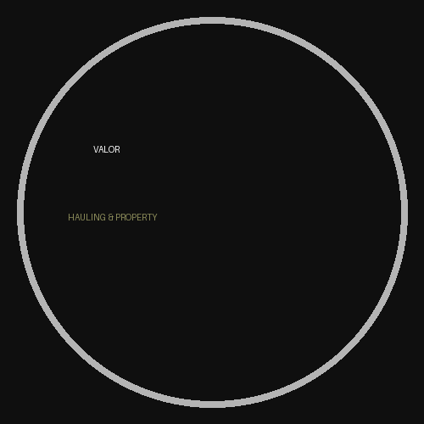
Call or Message Today for a Free Estimate

